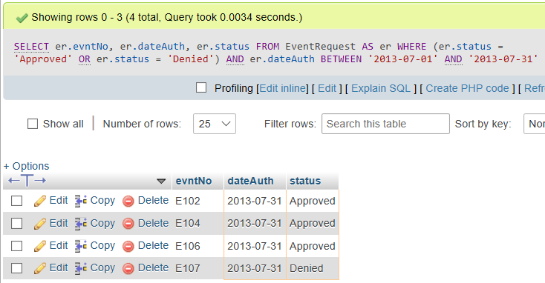

SELECT

er.evntNo,

er.dateAuth,

er.status

FROM EventRequest AS er

WHERE (er.status = 'Approved' OR er.status = 'Denied') AND er.dateAuth BETWEEN '2013-07-01' AND '2013-07-31';